# **PART 1: Operating System Installation Documentation**

**File Name:** OS_ITBED_Name Bekalu Adugna_ID 1600749  
**Submission Date:** 27/04/2018 E.C.

## **1. Documentation Structure**

### **a. Introduction**

* **Background:** Red Hat Enterprise Linux (RHEL) is a commercial, open-source Linux distribution developed by Red Hat for the commercial market. It is widely known for its stability, security, and high performance in server environments. Virtualization allows us to run RHEL in an isolated environment without formatting the main physical computer.
* **Motivation:** This project is intended to provide hands-on experience with the RHEL ecosystem, which is an industry standard for enterprise server administration, using a safe virtual environment.

### **b. Objectives**

1. To demonstrate understanding of OS installation procedures using a safe, controlled virtual environment.
2. To apply theoretical OS concepts (boot process, file systems like XFS, partitioning) in a practical setup.
3. To develop troubleshooting skills related to OS deployment.
4. To experiment with OS features through virtual machine tools.

### **c. Requirements**

**i. Hardware (Host Machine)**

* **Processor:** Intel Core i5 / AMD Ryzen 5 (Virtualization Technology VT-x/AMD-V enabled)
* **RAM:** 8GB or higher (recommended to allocate 4GB to the VM)
* **Storage:** 20GB+ free disk space

**ii. Software**

* **Virtualization Tool:** Oracle VirtualBox (recommended) or VMware Workstation.
* **ISO File:** rhel-baseos-9.x-x86_64-dvd.iso (Downloaded from the Red Hat Developer portal).

### **d. Installation Steps**

*(Note: You must insert your own screenshots for these steps as per the instructions)*

1. **VM Creation:**
   * Open VirtualBox -> Click "New".[[1](https://vertexaisearch.cloud.google.com/grounding-api-redirect/AUZIYQHnLPw6WzLTxkJRd8_mhsAuIDqW5KP9IGC875YL2fSGh5N0FtYdYzKsUlU2nc3KQg3UxmLvJ1kW3m_lvs3dBO8mC9zPp29azoURxLeg_wp1tS9Q98CjspIyTtG2huXl8qfOAh7yZJe0vXQtvNTxb_mzV2b1YrfK1W4YHzT2JXEImGiupJhZM65_)][[2](https://vertexaisearch.cloud.google.com/grounding-api-redirect/AUZIYQGFjWT5JuTivO3R9I9i2Qum9fReWd_QkiB05d-8JkGNWQK5u-3aQrKQy-eyTo7J2yoEOUZW_eaM7HAGG4Yj-eLxoXOlhNN5nvCtSiQPyxQ5XSI1bXvhylLc07Uz7iXpK-U0E133ZLOIZ5xlDCzEhPUpfFTfY-X7ibm0L951qnb2BJfwv1sIjvnxwlycjUrcyC9-z4pQuuM=)]
   * **Name:** RHEL_YourName
   * **Type:** Linux
   * **Version:** Red Hat (64-bit)[[1](https://vertexaisearch.cloud.google.com/grounding-api-redirect/AUZIYQHnLPw6WzLTxkJRd8_mhsAuIDqW5KP9IGC875YL2fSGh5N0FtYdYzKsUlU2nc3KQg3UxmLvJ1kW3m_lvs3dBO8mC9zPp29azoURxLeg_wp1tS9Q98CjspIyTtG2huXl8qfOAh7yZJe0vXQtvNTxb_mzV2b1YrfK1W4YHzT2JXEImGiupJhZM65_)][[3](https://vertexaisearch.cloud.google.com/grounding-api-redirect/AUZIYQEjFnn5dyP1iaa1Rp6Po30Umhd4-dmpIFq3qMZWBD7TtkzoJfn1OoOZwwlB9Gm88LagTV-FZFaGz-G6nOfsfOazjzw4p7cVunwaiuWXzgatyebkXJbqH2Huixn8Xe9nL6SdMX-l-P0_jXLUl_VUBv9IoUePQvPIxt4j3W1YZmD06TC3ntNeJHgxVG9t96DrtmryVawscHO0K7_56gGPkaz0nCt6ow==)]
   * **Memory:** Allocated 4096 MB (4GB).
   * **Disk:** Created a 20GB virtual hard disk (VDI).
   * 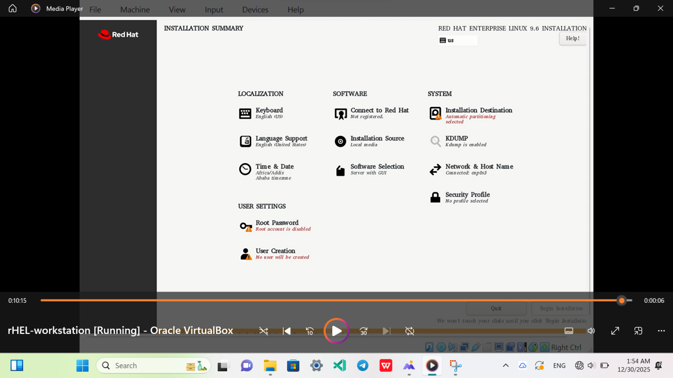
2. **ISO Mounting:**
   * Go to Settings -> Storage -> Empty (Optical Drive) -> Select the RHEL ISO file.
3. **Boot Process:**
   * Started the VM. Selected "Install Red Hat Enterprise Linux 9.x" from the GRUB boot menu.
   * *(Insert Screenshot of the black boot screen with white text here)*
4. **Language Selection:**
5. 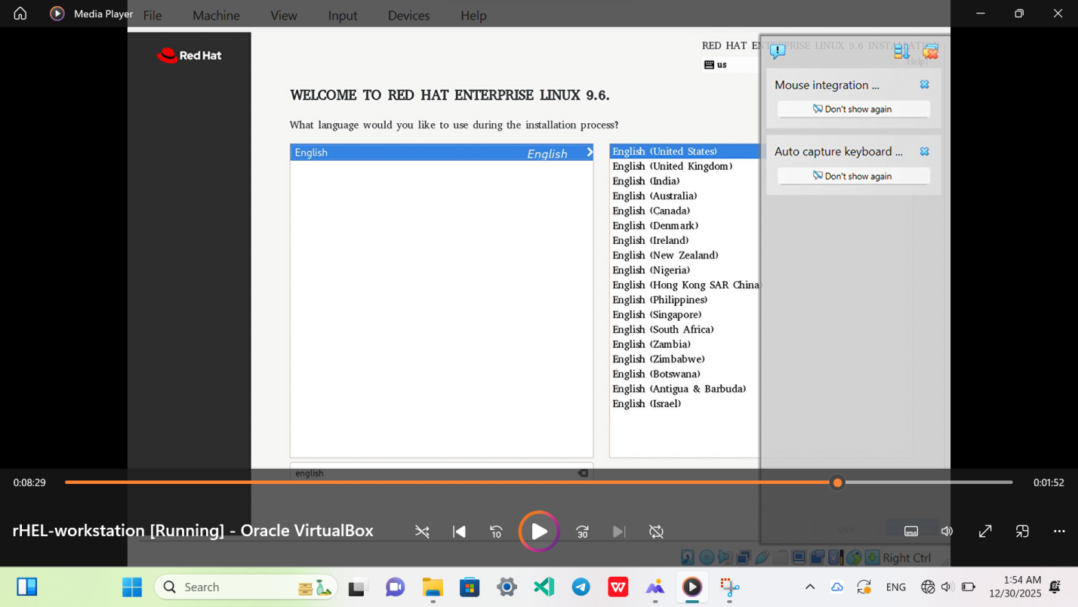
   * Selected "English (United States)" and clicked Continue.[[1](https://vertexaisearch.cloud.google.com/grounding-api-redirect/AUZIYQHnLPw6WzLTxkJRd8_mhsAuIDqW5KP9IGC875YL2fSGh5N0FtYdYzKsUlU2nc3KQg3UxmLvJ1kW3m_lvs3dBO8mC9zPp29azoURxLeg_wp1tS9Q98CjspIyTtG2huXl8qfOAh7yZJe0vXQtvNTxb_mzV2b1YrfK1W4YHzT2JXEImGiupJhZM65_)]
6. **Installation Destination (Partitioning):**
   * Clicked on "Installation Destination".[[1](https://vertexaisearch.cloud.google.com/grounding-api-redirect/AUZIYQHnLPw6WzLTxkJRd8_mhsAuIDqW5KP9IGC875YL2fSGh5N0FtYdYzKsUlU2nc3KQg3UxmLvJ1kW3m_lvs3dBO8mC9zPp29azoURxLeg_wp1tS9Q98CjspIyTtG2huXl8qfOAh7yZJe0vXQtvNTxb_mzV2b1YrfK1W4YHzT2JXEImGiupJhZM65_)][[3](https://vertexaisearch.cloud.google.com/grounding-api-redirect/AUZIYQEjFnn5dyP1iaa1Rp6Po30Umhd4-dmpIFq3qMZWBD7TtkzoJfn1OoOZwwlB9Gm88LagTV-FZFaGz-G6nOfsfOazjzw4p7cVunwaiuWXzgatyebkXJbqH2Huixn8Xe9nL6SdMX-l-P0_jXLUl_VUBv9IoUePQvPIxt4j3W1YZmD06TC3ntNeJHgxVG9t96DrtmryVawscHO0K7_56gGPkaz0nCt6ow==)]
   * Selected the 20GB Virtual Disk.
   * Selected "Automatic" for storage configuration and clicked "Done".
   * *(Insert Screenshot of the Installation Destination screen)*
7. **Software Selection:**
   * *Important Step:* Clicked "Software Selection" and chose **"Server with GUI"** (so the desktop environment loads) or "Workstation".
8. **User & Account Creation:**
   * **Root Password:** Set a strong root password.
   * **User Creation:** Created a user account.
   * **Full Name:** [Bekalu Adugna]
   * **Username:** [ ID 1600749]
   * 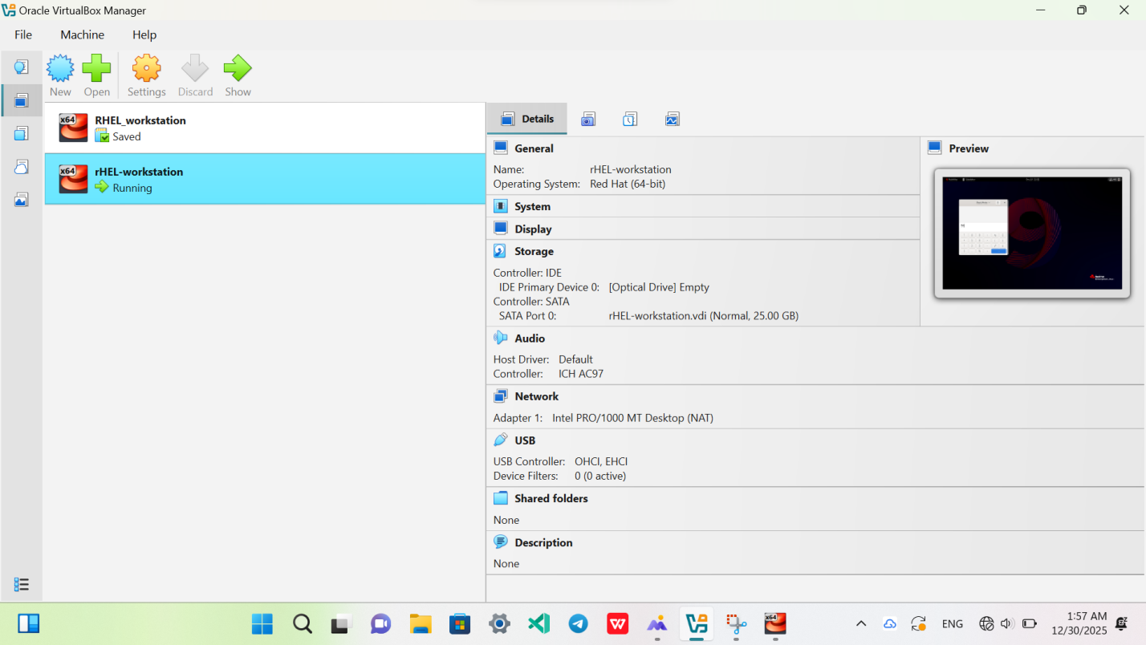
   * *(Insert Screenshot showing your name in the user creation field)*
9. **Final Installation:**
   * Clicked "Begin Installation".[[1](https://vertexaisearch.cloud.google.com/grounding-api-redirect/AUZIYQHnLPw6WzLTxkJRd8_mhsAuIDqW5KP9IGC875YL2fSGh5N0FtYdYzKsUlU2nc3KQg3UxmLvJ1kW3m_lvs3dBO8mC9zPp29azoURxLeg_wp1tS9Q98CjspIyTtG2huXl8qfOAh7yZJe0vXQtvNTxb_mzV2b1YrfK1W4YHzT2JXEImGiupJhZM65_)][[2](https://vertexaisearch.cloud.google.com/grounding-api-redirect/AUZIYQGFjWT5JuTivO3R9I9i2Qum9fReWd_QkiB05d-8JkGNWQK5u-3aQrKQy-eyTo7J2yoEOUZW_eaM7HAGG4Yj-eLxoXOlhNN5nvCtSiQPyxQ5XSI1bXvhylLc07Uz7iXpK-U0E133ZLOIZ5xlDCzEhPUpfFTfY-X7ibm0L951qnb2BJfwv1sIjvnxwlycjUrcyC9-z4pQuuM=)][[3](https://vertexaisearch.cloud.google.com/grounding-api-redirect/AUZIYQEjFnn5dyP1iaa1Rp6Po30Umhd4-dmpIFq3qMZWBD7TtkzoJfn1OoOZwwlB9Gm88LagTV-FZFaGz-G6nOfsfOazjzw4p7cVunwaiuWXzgatyebkXJbqH2Huixn8Xe9nL6SdMX-l-P0_jXLUl_VUBv9IoUePQvPIxt4j3W1YZmD06TC3ntNeJHgxVG9t96DrtmryVawscHO0K7_56gGPkaz0nCt6ow==)][[4](https://vertexaisearch.cloud.google.com/grounding-api-redirect/AUZIYQF8ABaa5sQyAfU-dMBgWpF8zGF2Jbn0hhnuv-NalSk_LHcnKuW9ZMJwXugI9nDtb7x3f0HU7Kmz6Ai7H9y5Ek76dWQ2aMWD_KmrLHHzwDiv8pRw2vFgZYJQsvPSIr-YXs9rAJzrMpK2zv4Bf64quJvCEv5Cb2I_B4ExGUSyky4zXN58wibvM2dBtyPmaQi6MiYF1nsRvgUquqLLTxZN6WWat17BEXWENfJiBFE=)] After completion, clicked "Reboot System".[[1](https://vertexaisearch.cloud.google.com/grounding-api-redirect/AUZIYQHnLPw6WzLTxkJRd8_mhsAuIDqW5KP9IGC875YL2fSGh5N0FtYdYzKsUlU2nc3KQg3UxmLvJ1kW3m_lvs3dBO8mC9zPp29azoURxLeg_wp1tS9Q98CjspIyTtG2huXl8qfOAh7yZJe0vXQtvNTxb_mzV2b1YrfK1W4YHzT2JXEImGiupJhZM65_)][[3](https://vertexaisearch.cloud.google.com/grounding-api-redirect/AUZIYQEjFnn5dyP1iaa1Rp6Po30Umhd4-dmpIFq3qMZWBD7TtkzoJfn1OoOZwwlB9Gm88LagTV-FZFaGz-G6nOfsfOazjzw4p7cVunwaiuWXzgatyebkXJbqH2Huixn8Xe9nL6SdMX-l-P0_jXLUl_VUBv9IoUePQvPIxt4j3W1YZmD06TC3ntNeJHgxVG9t96DrtmryVawscHO0K7_56gGPkaz0nCt6ow==)][[5](https://vertexaisearch.cloud.google.com/grounding-api-redirect/AUZIYQHK3CrXbXliLHCquo-9fkfOkqTIlVIajjEEuzKZ9FqfkX6HZI1TQrQIHlyFXT5fb1fU1ByPMJEwglC6OYziHMLixqOTZcYNie6MboZZeBB00Eq2YD1sWDzHuTKLbFgAejVceaGOdLM=)]
   * 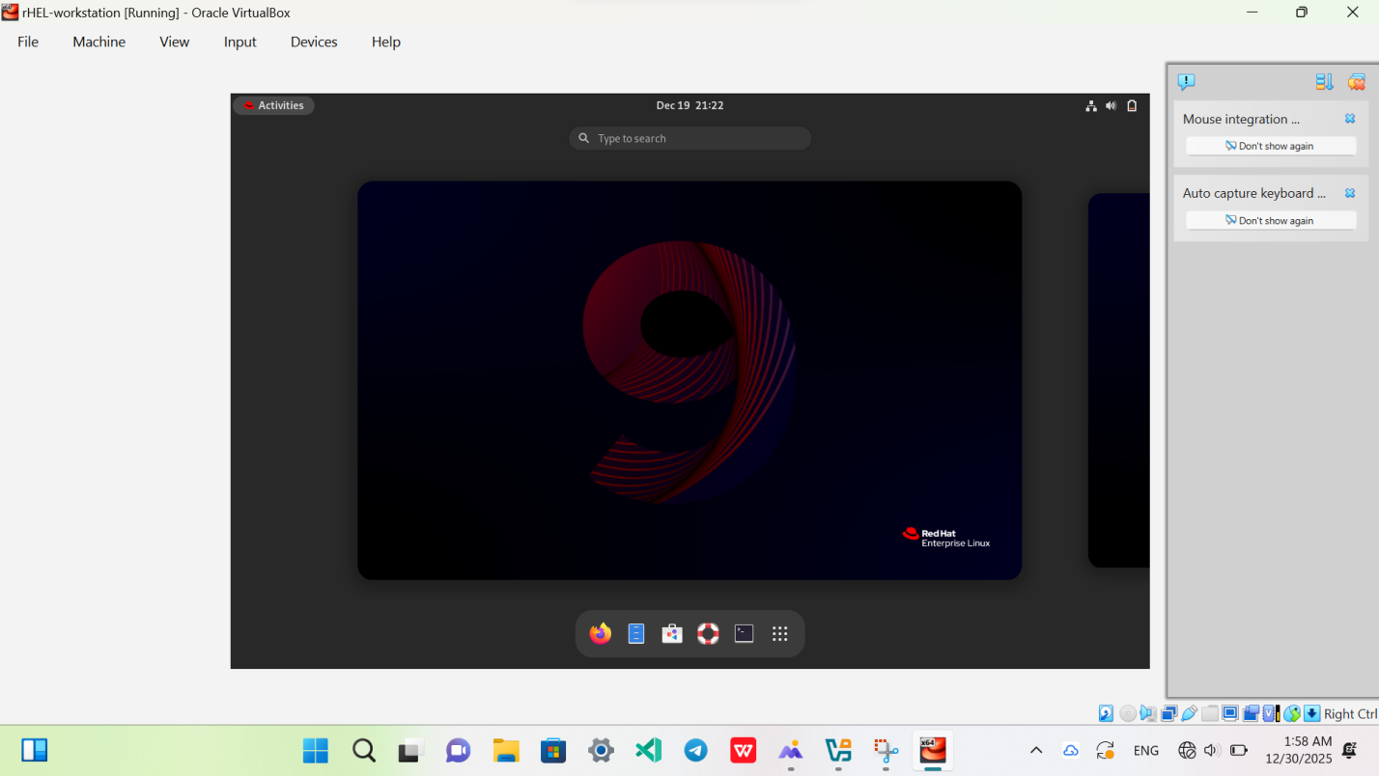
10. **Desktop/Home Screen:**
    * Logged in with the new user.[[3](https://vertexaisearch.cloud.google.com/grounding-api-redirect/AUZIYQEjFnn5dyP1iaa1Rp6Po30Umhd4-dmpIFq3qMZWBD7TtkzoJfn1OoOZwwlB9Gm88LagTV-FZFaGz-G6nOfsfOazjzw4p7cVunwaiuWXzgatyebkXJbqH2Huixn8Xe9nL6SdMX-l-P0_jXLUl_VUBv9IoUePQvPIxt4j3W1YZmD06TC3ntNeJHgxVG9t96DrtmryVawscHO0K7_56gGPkaz0nCt6ow==)][[5](https://vertexaisearch.cloud.google.com/grounding-api-redirect/AUZIYQHK3CrXbXliLHCquo-9fkfOkqTIlVIajjEEuzKZ9FqfkX6HZI1TQrQIHlyFXT5fb1fU1ByPMJEwglC6OYziHMLixqOTZcYNie6MboZZeBB00Eq2YD1sWDzHuTKLbFgAejVceaGOdLM=)]
    * *(Insert Screenshot of the RHEL Desktop with the "Activities" bar)*

### **e. Issues (Problems Faced)**

1. **Network Disconnected:** By default, RHEL keeps the network interface disconnected after install.
2. **Subscription Warning:** RHEL requires a subscription to install packages via dnf/yum.
3. **Resolution:** The screen size was small (800x600) inside the VM.

### **f. Solution**

1. **Network:** Clicked the network icon in the top right corner and selected "Connect". Enabled "Connect automatically" in settings.
2. **Subscription:** Registered for a free "Red Hat Developer Subscription" and used the command subscription-manager register to activate.
3. **Resolution:** Installed VirtualBox Guest Additions to enable dynamic screen resizing.

### **g. Filesystem Support**

* **Filesystem:** **XFS**
* **Why?** RHEL uses **XFS** as its default file system (instead of ext4).[[6](https://vertexaisearch.cloud.google.com/grounding-api-redirect/AUZIYQEzFjk1xL4nSakTCoa9vP_OC7mSuffqe4VBRjS5aS1obfcbnQLUX-e8WqaB05Jkp6a1uwSUX7pS-cJhX5cIhPkY64Ckp0HPa2wUttzqyCrgnmfaJMWkafJCR2WBtvJflWji_UiacGC7K6Z5H4jvZGoyuFKoa_Xpq7VgmbvVjyUx1NmdBItRzClz-172tr9I-anRZc719It4rTJvvMQOj8S2nLVMedtdUUdn3ZlkooFCRiPa)][[7](https://vertexaisearch.cloud.google.com/grounding-api-redirect/AUZIYQH8Ogerx44OuWAj2TIT0FjhWQ-SF7nloCXszx_QvsnnksxTCvW7-WP_DLPHc8y6GCxAA-R4RAZ-6x7DfZ4Tn-BZSl7i907PrStqL1kpeuYn-fNx5Z30YOczwOfpw8Hjgk6ta015wWh0aBKpWJlnPxhmZgoopCKrZiMfPF9TMhJ5onRct1mjHqobGjedzGs6QOBkyk0TM2U6zsX578VrwnABQuPGwqJnNeXpw7Z8nDD2-Dk7uWSi_MOD7sX8XRrkxZ544Tp-8l7umLBQwYUUzEZvuDHu)] XFS is a high-performance 64-bit journaling file system. It is chosen for RHEL because it excels at handling large files, offers rapid formatting, and is highly scalable for enterprise server needs.

### **h. Advantages and Disadvantages (of Virtualization)**

* **Advantage:** Allows testing of enterprise-grade server OS (RHEL) without buying a dedicated server. Snapshots allow rolling back if a configuration breaks the system.
* **Disadvantage:** RHEL with a GUI is heavy; it may run slowly if the host machine has limited RAM (less than 8GB).

### **i. Conclusion**

Installing RHEL provided insight into enterprise Linux environments.[[4](https://vertexaisearch.cloud.google.com/grounding-api-redirect/AUZIYQF8ABaa5sQyAfU-dMBgWpF8zGF2Jbn0hhnuv-NalSk_LHcnKuW9ZMJwXugI9nDtb7x3f0HU7Kmz6Ai7H9y5Ek76dWQ2aMWD_KmrLHHzwDiv8pRw2vFgZYJQsvPSIr-YXs9rAJzrMpK2zv4Bf64quJvCEv5Cb2I_B4ExGUSyky4zXN58wibvM2dBtyPmaQi6MiYF1nsRvgUquqLLTxZN6WWat17BEXWENfJiBFE=)] Unlike consumer Linux (Ubuntu/Mint), RHEL focuses heavily on stability, user permissions, and subscription management.

### **j. Future Outlook / Recommendation**

RHEL is the industry standard for corporate data centers and cloud infrastructure. Learning it is essential for careers in System Administration and DevOps.

## **2. Theory Question: Virtualization**

**What is it?**Virtualization is the technology that allows you to create multiple simulated environments or dedicated resources from a single physical hardware system.

**Why use it?**It allows for server consolidation (running multiple servers on one machine), improves disaster recovery (VMs are just files that can be copied), and provides isolated environments for safe testing.

**How does it work?**It uses a software layer called a **Hypervisor** (such as KVM, ESXi, or VirtualBox). The hypervisor sits on top of the physical hardware and creates a virtual layer, allocating CPU, RAM, and Storage to "Virtual Machines" (guests) while keeping them separate from the host hardware.